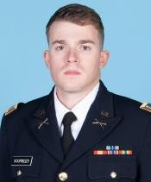
CPT JOSHUA SOURBEER
US ARMY SIMULATIONS OFFICER
2700 CHEVAL ST #104, ORLANDO FL 32828
JSOURBEER999@GMAIL.COM;
412-918-6233

OBJECTIVE MILITARY WORK EXPERIENCE
Experienced Military Officer,

with a background as an Infantry Platoon Leader and current technical expertise as a Simulation Officer; currently enrolled at UCF in Modeling/Simulation MA
- Pennsylvania National Guard (2013-2017)
- Platoon Leader, Unit Movement Officer, 3D Cavalry Regiment (2018-2020)
- MTC Chief of Small Unit Training (2021-2024)
  - Daily Management of Virtual Battlespace 3 Suites and Other Virtual Simulations

WORK EXPERIENCE CIVILIAN EDUCATION & RELEVANT SKILLS
    - University of Pittsburgh at Bradford (2013-2017)

- Managed a portfolio of approximately 50 Military Simulations for Soldier Training
- Supervised a staff of 15 contracted employees inside a large organization providing simulation support to Army units throughout the Pacific.
- Managed a suite of 7 vLANs with associated Network Devices (Switches, Servers, Domain Controllers, Wire Infrastructure, and over 300 Gaming Computers)
- Oversaw tasks such as Software Sprints, Hardware Upgrades, Digital Terrain, Model and Building Creative Projects, Verification, Validation and Accreditation of Gaming Based Simulation Enablers
  - Varsity Athlete (Soccer & Cross Country)
  - Summa Cum Laude, 3.82 GPA
  - Minor in Forensics
- University of Central Florida (2024-Present)
  - Current GPA: 4.0
- 3 Years Experience Using Blender, for Digital Asset Creation, 3D Model Building
- 2 Years Experience in C#, Red Hat Linux, VBA
- 1 Year Experience in Java Script, Python
- 2 Years Experience With Unreal Engine/Unity

CERTIFICATIONS, SCHOOLS

- Army Simulations Operations Course (SOC)
- Certified Modeling & Simulation Professional Certification (National Training & Simulation Association)
- Comptia Security Plus/Network Plus


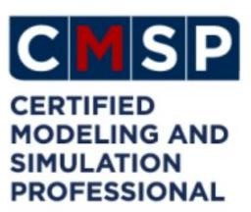


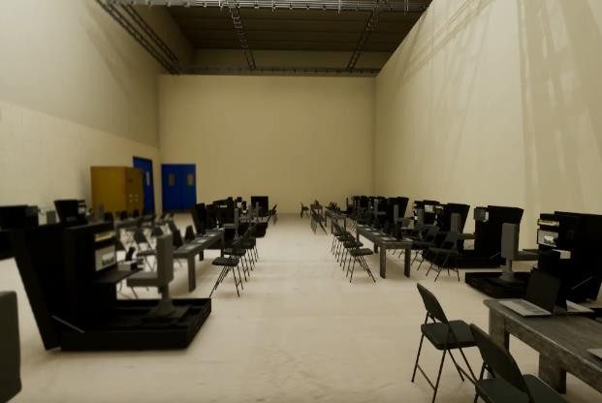

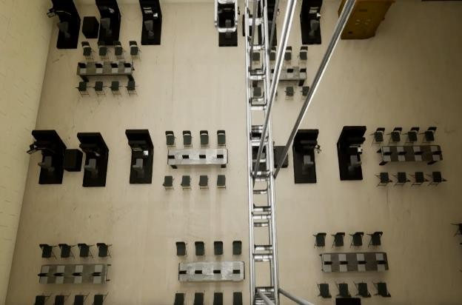

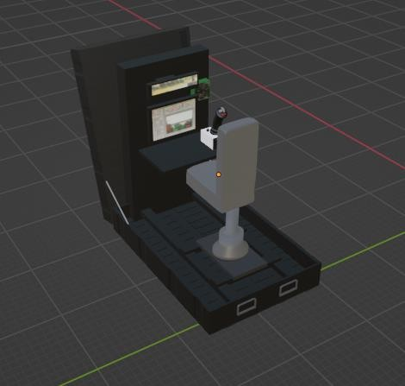
Created an Accurately Scaled 3D Blueprint of a Large Bay and New PEO-STRI built Simulators. Created from Scratch in Blender, Rendered in UE5. This Enabled Senior Leaders (O5 & GS14) to Visualize Over $6 Million Dollars Work of Complex Simulation Equipment in a Templated Location, Saving Installation Time and Money in Future Years.
Relevant Technical Skills & Portfolio


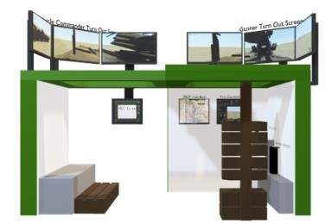

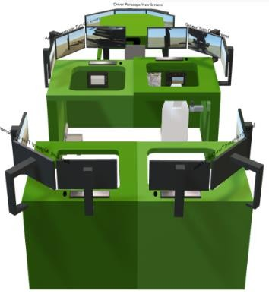

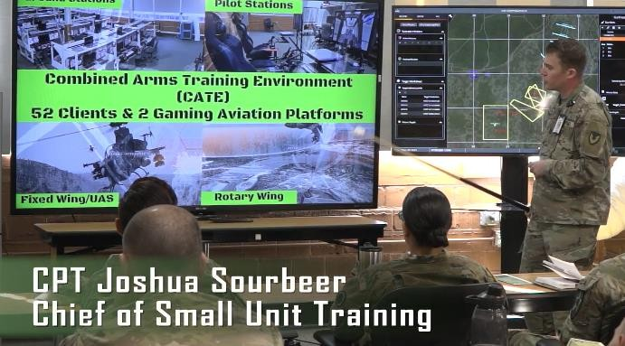

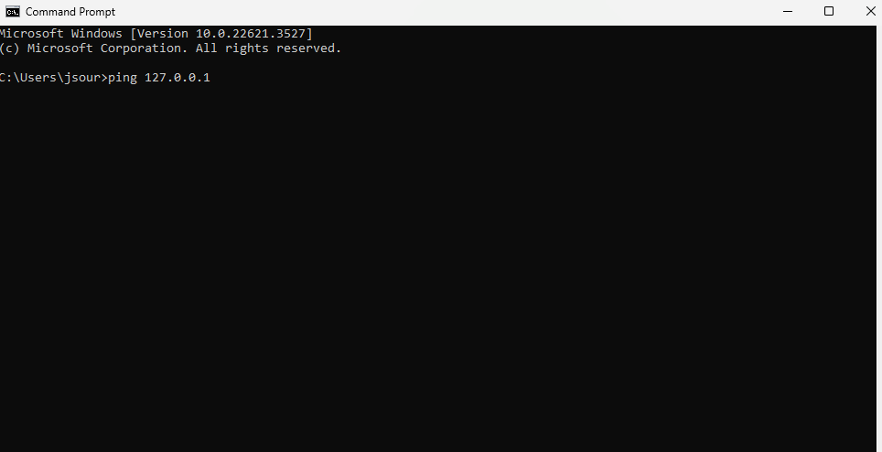

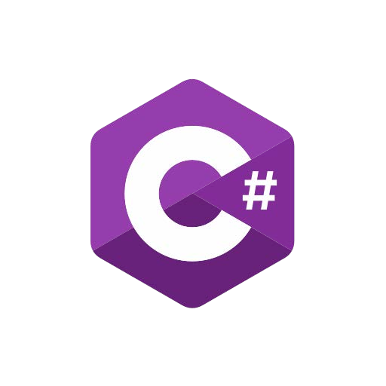

Created Various Other 3D Models of US Army Simulators For Use In Routine Capabilities Briefings Attended By Commanders, Non-Commissioned Officers, and Various Senior Leaders Including Several Two and Three Star General Officers and Civilian O6 Equivalents (GS14-15)


Wide Variety of Technical Knowledge in OSI Layer 1-3 Troubleshooting and Network Management to Include Sys Admin level of knowledge on CMD Prompt, Linux, C# and Visual Basic. Wrote a Visual Basic Macro Enabled Script to Allow Gaming Instructors to Ping all 400 Games for Training Laptops at MTC-JBLM. Managed and Provided Government Oversight to a small staff of 13x Gaming/Training Instructors and 2x System Administrators. Guided an Organization Through Various Hardware/Software Upgrades, License Renewals, New Equipment Issuances, Windows Upgrades, Etc. Currently developing an RPG Game and Mobile Application.

